# 

# Rich Heritage

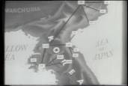Only nine years after the bombing of Pearl Harbor, the United States found itself once again in the throes of an unexpected war-this time on the Korean Peninsula. But the U.S. had seriously downsized its cryptologic operations at the end of World War II. And the remaining resources were focused on the Soviet Union.

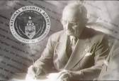The Nations' military and civilian codemakers and codebreakers needed to be united. With the stroke of his pen, President Truman created one truly integrated organization-the National Security Agency. NSA opened its doors in November 1952-building on the legacy of its predecessor-the Armed Forces Security Agency.

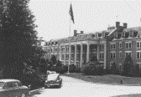The National Security Agency began supporting warfighters on the Korean battlefields from its headquarters in Washington, DC. NSA cryptologists helped General Walker avoid enemy fire on the Pusan Perimeter and set the groundwork for General McArthur's victorious landing at Inchon.

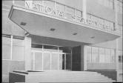After the armistice, U.S. leaders once again turned their attention to the Soviet threat. The Soviets had begun building and testing nuclear weapons. Atomic bomb hysteria swept the Nation's capital. The Joint Chiefs of Staff believed the city would be a potential bombing target. So NSA moved to its current location at Fort Meade, Maryland, in 1957.

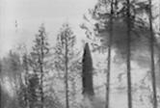By 1961, Cold War tensions took us to the brink of a nuclear war. The Nation's worst nightmare was confirmed. In a speech by President Kennedy, he announced "unmistakable evidence has established the fact that a series of offensive missile sites is now in preparation on the island of Cuba." President Kennedy imposed a strict blockade on military shipments to Cuba. If the Soviets were to challenge the U.S. Fleet, it could mean war.

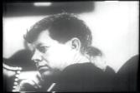NSA closely monitored the Russian Fleet's movement. The Agency would be among the first to inform Kennedy when the Russians stood down. Signals Intelligence helped Kennedy to avoid a nuclear war.

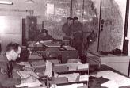A great victory of the Cold War was won, but a crisis was festering in Southeast Asia. U.S. cryptologists were dispatched to Vietnam-four years before America's full military involvement. To intercept the adversary's communications, they had to get close to enemy lines-and would be among the first American casualties. When U.S. troops returned home, NSA cryptologists stayed behind to provide intelligence and secure communications support to the U.S. embassy. They stayed until it was almost too late.

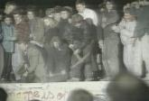The end of the Cold War emphasized the value of Signals Intelligence and Information Assurance. NSA continued to support policymakers and combatant commanders in conflicts around the globe with real-time actionable intelligence and state-of-the-art secure communications.

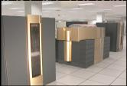NSA's research contributed significantly to the development of the Super Computer, the cassette tape, the microchip, quantum mathematics, nanotechnology, biometrics, and semiconductor technology.

As the turn of the century approached, new challenges emerged. NSA would need to be more agile than ever before.

# National Asset

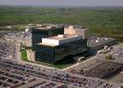Here at the National Security Agency mathematicians, linguists, engineers, and computer scientists focus on two core missions: Information Assurance-code making, and Signals Intelligence-codebreaking.

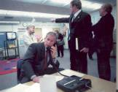Information Assurance prevents America's adversaries from exploiting sensitive U.S. government communications by giving policymakers and warfighters a secure means of communicating. NSA products allow the President of the United States to communicate securely wherever he is. War fighters on the front line can discuss their operations and get critical intelligence information quickly without fear that the enemy is listening.

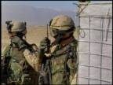NSA also develops and produces the command and control systems that protect U.S. military operations and keep U.S. weapons systems from unauthorized use. These Information Assurance products and services allow NSA's customers to communicate securely anywhere in the world in real time. Even in space.

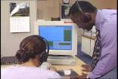While NSA's codemakers are keeping U.S. government communications secure, NSA's codebreakers are exploiting foreign adversaries' communications-a discipline known as Signals Intelligence, or SIGINT. NSA experts collect, process, and analyze foreign signals. Their reports give policymakers and warfighters a decisive edge.

NSA customers use this information to counter terrorism, prevent the proliferation of weapons of mass destruction and thwart the flow of narcotics into our country.

NSA's missions depend on the expertise of a joint military and civilian workforce. These codemakers and codebreakers have been inventing new technology, preventing conflict, shortening wars, and saving lives since 1952.

# Signals Intelligence

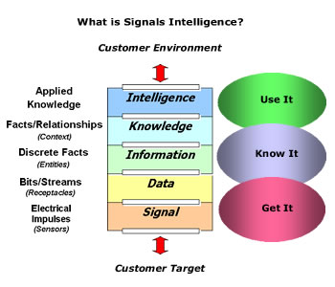The National Security Agency collects, processes and disseminates foreign Signals Intelligence (SIGINT). The old adage that "knowledge is power" has perhaps never been truer than when applied to today's threats against our nation and the role SIGINT plays in overcoming them.

NSA's SIGINT mission protects the nation by:

* Providing information in the form of SIGINT products and services that enable our government to make critical decisions and operate successfully.
* Protecting the rights of U.S. citizens by adhering to the provisions of the 4th amendment to the Constitution.
* Using the nation's resources responsibly, according to the best management processes available.

SIGINT is derived from the signals environment that is described by the graphic above. Other agencies within the Intelligence Community are responsible for other types of intelligence:

* Human Intelligence (HUMINT) is primarily the responsibility of the [CIA](http://www.cia.gov) and [DIA](http://www.dia.mil),
* Imagery Intelligence (IMINT) belongs to [NGA](http://www.nima.mil),
* Military Intelligence and Measurement and Signature Intelligence (MASINT) belongs to [DIA](http://www.dia.mil).

Together, these different yet complementary disciplines give our nation's leaders a greater understanding of the intentions of our enemies.

NSA's SIGINT mission provides our military leaders and policy makers with intelligence to ensure our national defense and to advance U.S. global interests. This information is specifically limited to that on foreign powers, organizations or persons and international terrorists. NSA responds to requirements levied by intelligence customers, which includes all departments and levels of the United States Executive Branch.

The prosecution of the SIGINT mission has evolved from the relatively static, industrial age, Cold War communications environment to the ubiquitous, high speed, multi-functional technologies of today's information age. The ever-increasing volume, velocity and variety of today's communications make the production of relevant and timely intelligence for military commanders and national policy makers more challenging than ever.

NSA has a strong tradition of dedicated, highly qualified people deeply committed to maintaining the nation's security. While technology will obviously continue to be a key element of our future, NSA recognizes that technology is only as good as the people creating it and the people using it. NSA remains committed to its core mission of exploiting the Agency's deep analytical skill and technological capabilities to ensure the nation maintains a significant strategic advantage in the advancement of U.S. interests around the world.

As much as modern telecommunications technology poses significant challenges to SIGINT, the many languages used in the nations and regions of the world that are of interest to our military and national leaders require NSA to maintain a wide variety of language capabilities. Successful SIGINT depends on the skills of not only language professionals but those of mathematicians, analysts, and engineers, as well. The nation is indebted to them for the successes they have won.

SIGINT plays a vital role in our national security by employing the right people and using the latest technology to provide America's leaders with the critical information they need to save lives, defend democracy, and promote American values.

# NSA/CSS National Cryptologic Memorial

Top of Form

Bottom of Form

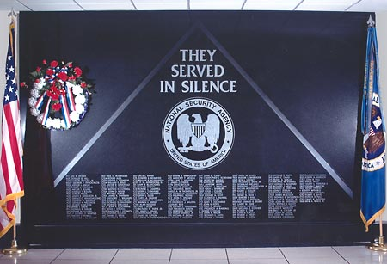

The National Security Agency/Central Security Service Cryptologic Memorial honors and remembers those who gave their lives, "serving in silence," in the line of duty. It serves as an important reminder of the crucial role that cryptology plays in keeping the United States secure and of the courage of these individuals to carry out their mission at such a dear price.

The wall, dedicated in 1996, lists 158 names of Army, Navy, Air Force, Marine, and civilian cryptologists who have made the ultimate sacrifice. The black granite memorial stands eight feet tall by 12 feet wide with the words THEY SERVED IN SILENCE etched into the polished stone at the cap of a triangle. The NSA seal is carved below followed by the names of those cryptologists who have given their lives in service to their country. The names are at the base of the triangle because these cryptologists and their ideals—dedication to mission, dedication to workmate, and dedication to country—form the foundation for cryptologic service. The structure was designed by an NSA employee, and the memorial is housed in the NSA headquarters complex. Click here for a [complete list of names](http://www.nsa.gov/memorial/memor00005.cfm) engraved on the wall.

On Memorial Day 2001, NSA began a tradition of declassifying and sharing the stories behind the names on the wall.